Blinking an LED with Python

By Alexa Hunleth  
February 25, 2017

# Running Python

When you get on to the Raspberry Pi, you will want to go to the Menu.





Then, click on the Programming section.

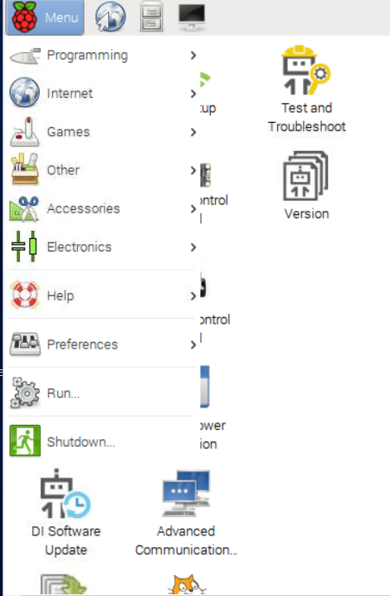



Now, click on Python 2 (IDLE). Don’t click Python 3 (IDLE) since it won’t work with the GrovePi+ board.

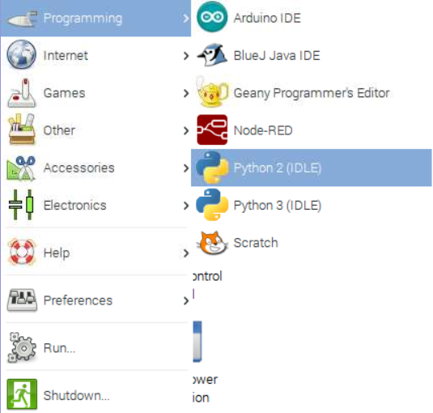



This is the Python 2 (IDLE) on the Raspberry Pi that you should be at.

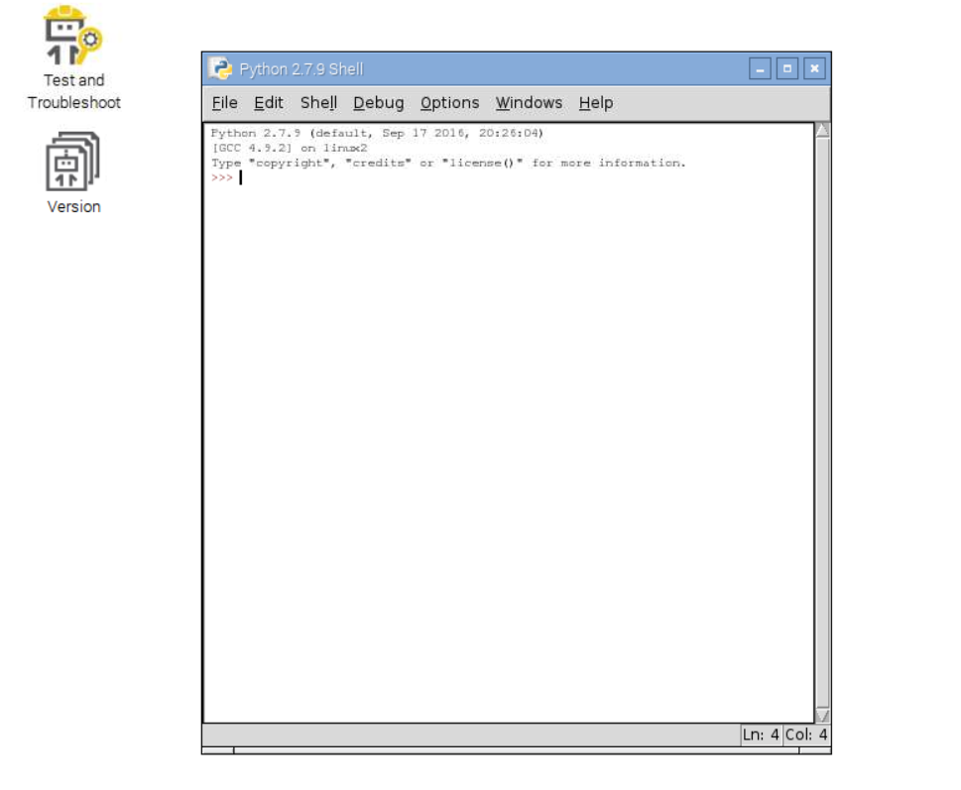



# Setting Up the LED



Take one of the LEDs out of the GrovePi+ Box (red, green, or blue, it doesn’t matter) and its bag.

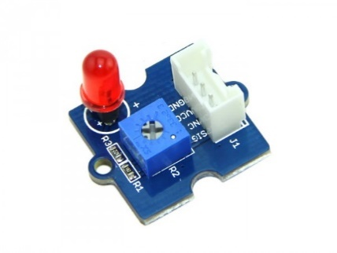

Put the LED in the two black tubes with metallic holes with the longer of the two LED wires in the positive black tube (look for the + sign on the board).

**If you can’t tell the difference between the lengths of the wires, put the LED in one direction. If the LED isn’t lighting up at the end, make sure that everything including the program is correct according to the pictures. Then if the LED still isn’t lighting up than switch the way the LED is oriented in the black sockets.**

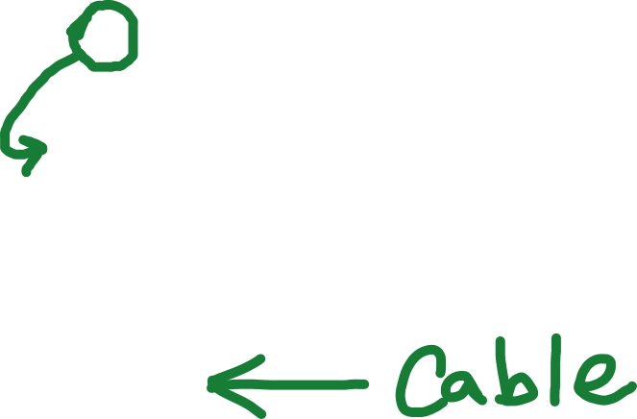

Next, hook the GrovePi+ cable to the LED’s white plastic connector.

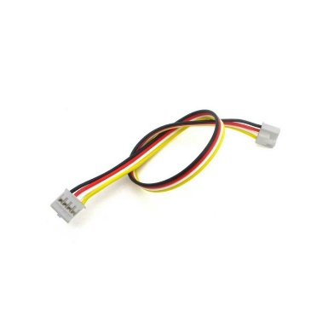

Lastly for this step, plug the other side of the cable into one of D (Digital but on the board the pins are labeled D with a number) pins on the blue GrovePi+ shield. **Remember the digital pin number for later!**

# Programming

Go to the Python 2 (IDLE) tab that you opened on the Raspberry Pi. Go to File and then to New File.

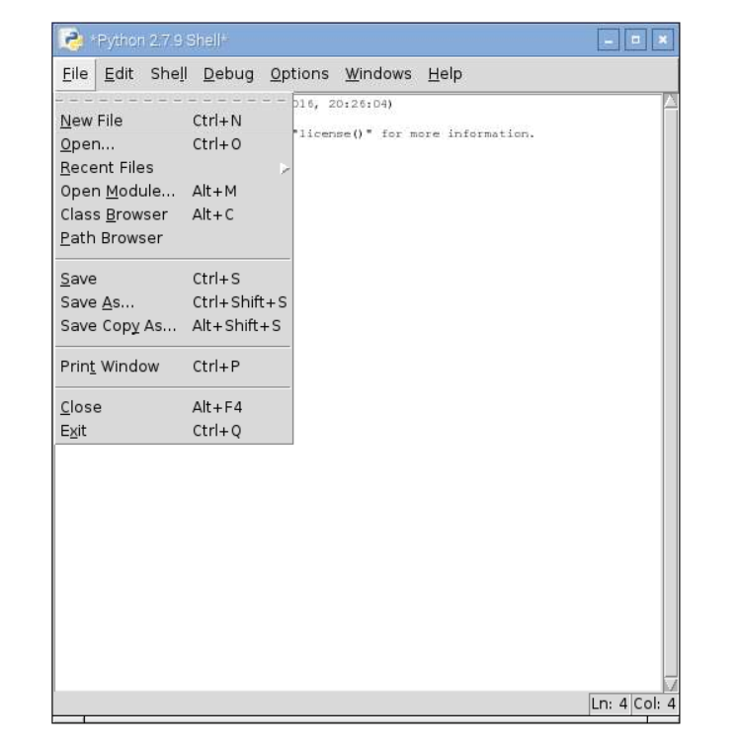



You are now in a file where you can make programs and change the lines unlike in the shell prompt. Your screen should look like this now!

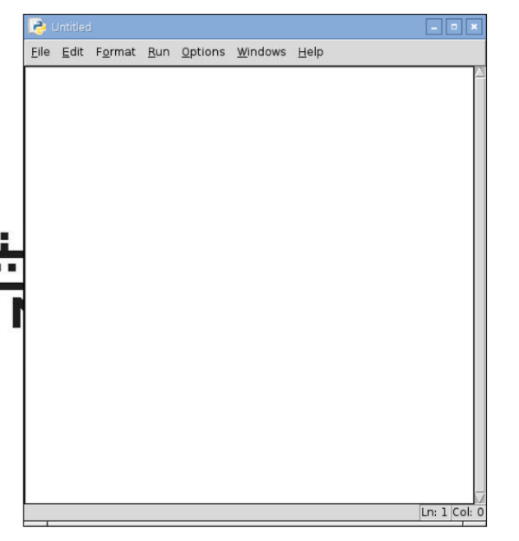

Now, time to start programming. First, we need to import programs to make programming the LED easier. Type this into the Python File.

from grovepi import * import time



The grovepi line of code enables us to turn the LED on and off and the time line of code enables us to us the phase time.sleep() to have the program wait. Next, add an empty line of code to separate the imported code from the main code of the program. Now, let’s turn the LED on!

digitalWrite(2, 1)



**Change the “2” to the pin number that your LED is attached to or else the program won’t work!!!** The “2” is the pin number that the program going to tell to turn on the LED, and the 1 means on like in binary. Also, 0 means off like in binary, so to turn of the LED, type …

digitalWrite(2, 0)



Now, we can turn the LED on and off, but there isn’t a break in between turning the LED on and off, so in order to see the LED flash, we need to add …

time.sleep(.1)



… in between turning the LED on and off. The .1 in the parenthesis is how many seconds the program waits, but the program doesn’t have to wait .1 seconds, it can wait for however long you want it to wait. Now, the program only blinks the light once, and to make the LED blink the LED multiple times, you need to change your program to look like this except keep your pin number the same as how you have it now.

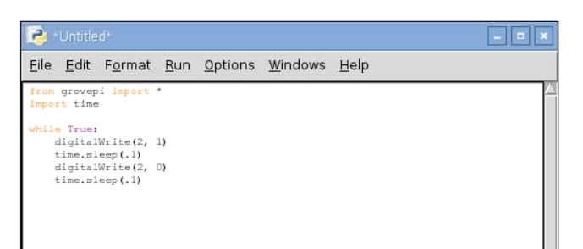

Make sure that all the indents are correct and that there are any spelling mistakes so that the program will work for you.

# Saving Your Work

To save your work, press the control and s buttons on the keyboard at the same time.

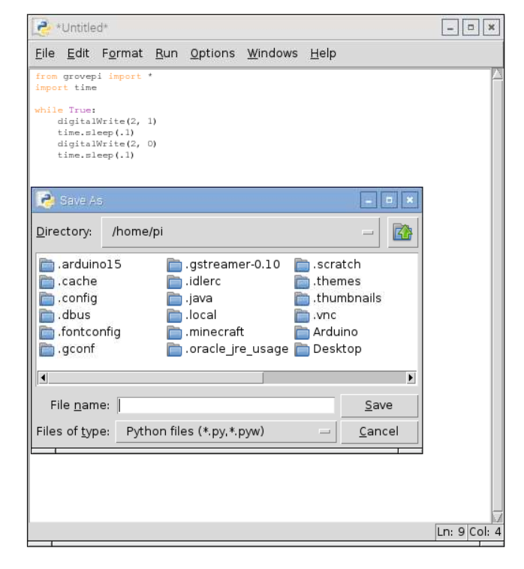



This window should pop up. Now, whenever you need to save your program, just hold down both control and s to save.

# Run Your Program

To run your program, you must save your program. To run your program, click the F5 key. To stop the program, just x out of the Python 2 shell.